**6. Emergency anaesthesia and airway management**

Most paediatric airways are straightforward to manage, and intubation is easy after neuromuscular blockade; however airway management in major trauma may be very challenging.

Difficulties may be increased by

* The unfamiliar environment
* Time pressure
* Multiple simultaneous interventions
* C spine stabilisation
* Trauma to face and neck with oedema and soiling of the airway with blood
* Agitated uncooperative child due to pain and hypoxaemia

Have a low threshold for seeking senior assistance. If difficulty is anticipated either due to underlying difficult anatomy or to airway trauma, and time allows, get senior anaesthetic and ENT assistance and assemble equipment before attempting to secure the airway.

**Oro-tracheal rapid sequence induction is the method of choice for securing the airway in paediatric major trauma,** however effective pre-oxygenation may not be possible. Young children desaturate rapidly and this may be exacerbated by major trauma leading to a significant risk of hypoxiaduring intubation. **Gentle** ventilation with 100% O2 post induction prior to intubation will allow for optimal relaxation and oxygenation prior to intubation.

Indications for **IMMEDIATE** intubation

* Airway obstruction
* Airway protection
* GCS<8
* Traumatic cardiac arrest

Consider **EARLY** intubation

* Hypoventilation
* Airway protection
* Burns, smoke inhalation
* Persistent hypoxaemia
* Haemorrhagic shock
* Severely injured child needing intervention in theatre/radiology
* To perform therapeutic and diagnostic procedures if uncooperative despite analgesia
* Stabilisation prior to transfer/retrieval
* Respiratory distress
* Cervical cord injury with evidence of respiratory insufficiency

**Induction drugs**

The drugs used for induction and their quantities will be based upon clinical assessment and the practitioner’s experience of their use. **This must include consideration of drugs recently given for analgesia and procedural sedation** in the pre-hospital phase of care.

It is strongly recommended that ketamine is used as the induction agent of choice in major trauma. It provides relative haemodynamic stability and a wide therapeutic margin (10-20% context specific overdose is unlikely to cause problems).

The following regimes are strongly recommended:

**Standard 3:2:1**

Fentanyl **3 microgram/kg**,Ketamine **2mg/kg** and Rocuronium **1mg/kg**

**Hypovolaemic 1:1:1**

Fentanyl **1 microgram/kg**,Ketamine **1mg/kg** andRocuronium **1mg/kg**

If **severe hypovolaemia** is suspected fentanyl may be omitted. In some very exceptional circumstances it may be appropriate to administer a paralysing agent alone.

**Top tips**

* Remove the front of the collar for intubation
* Have a low threshold for using a bougie or a stylet to minimise neck movement
* Consider a cuffed tracheal tube if there is airway soiling or the need for high pressure ventilation
* Use an uncut tube in burns and facial trauma
* Gastric distension can significantly compromise ventilation. Decompress the stomach with an orogastric or nasogastric tube
* Post intubation ventilate to normocarbia of 4.5 - 5kPa. Don’t rely on the absolute value of EtCO2, check a blood gas

**See Appendix 2 – Airway Algorithms including Surgical Airway**

**2a. Paediatric emergency anaesthesia - drugs**

**2b. Paediatric trauma intubation checklist**

**2c. Paediatric RSI kit dump**

**2d. Emergency anaesthesia flow chart including failed intubation / failed oxygenation**

**2e. Needle cricothyroidotomy**

**2f. Surgical cricothryoidotomy**

**Appendix 2a**

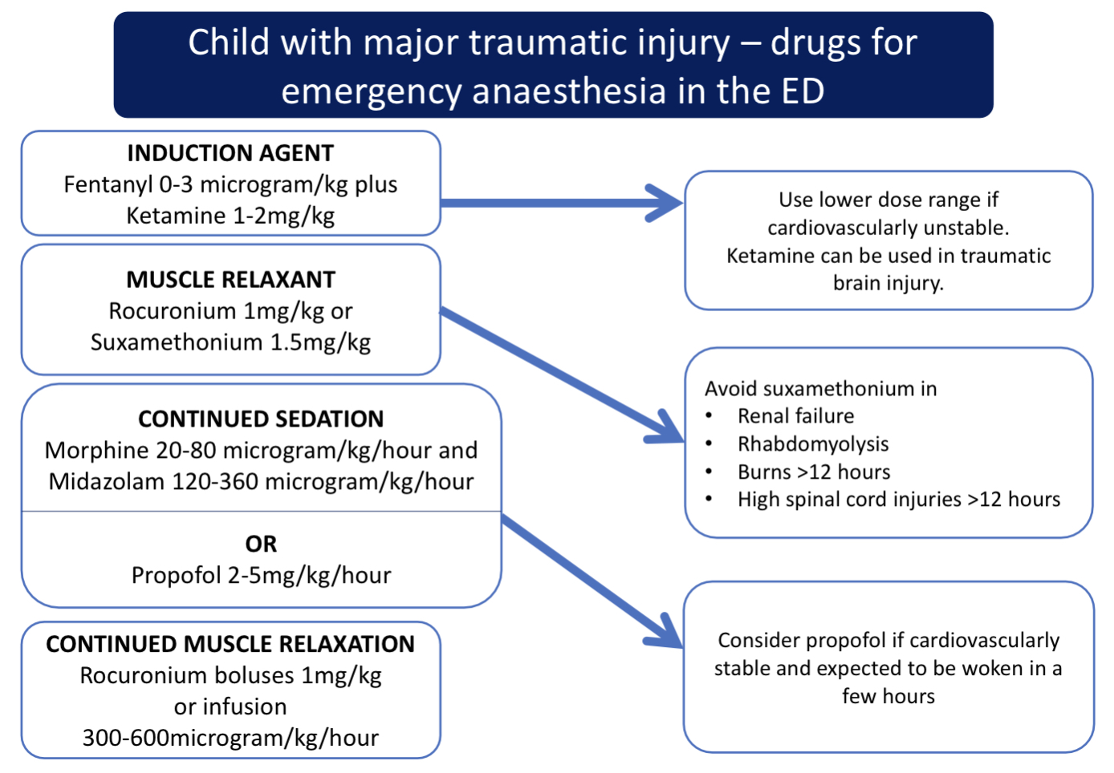

**Appendix 2b**

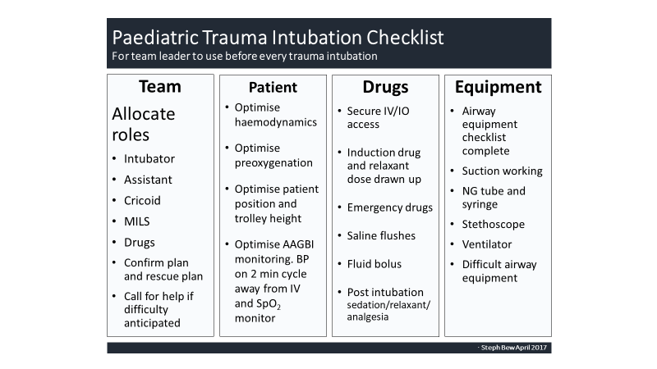

**Appendix 2c**

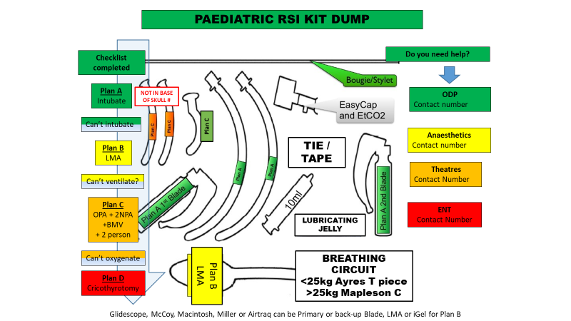

**Appendix 2d**

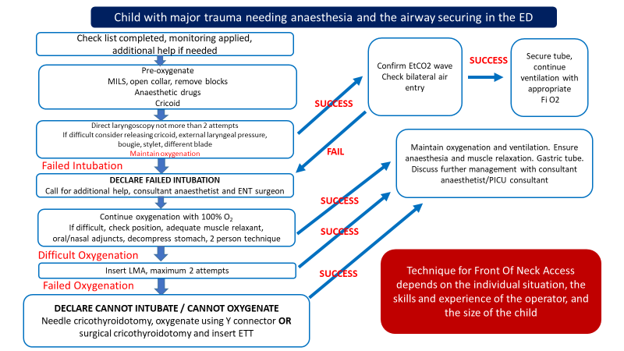

**Appendix 2e**

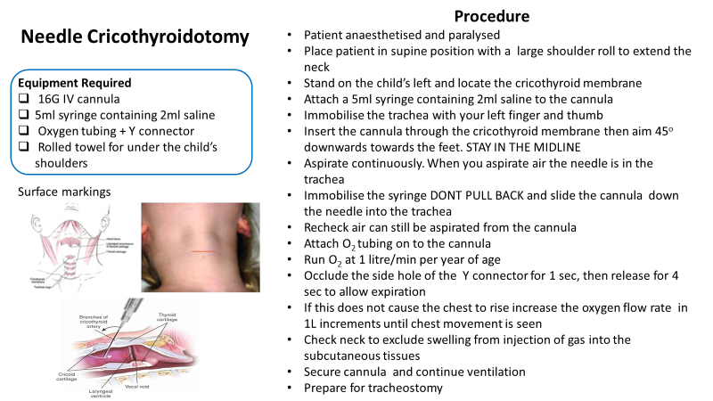

**Appendix 2f**

