20. Safeguarding and child protection

From ‘unexplained infant trauma syndrome’ in the early 20th century, society and medicine have evolved, ‘Safeguarding is everyone’s responsibility’- all of the professionals involved in delivering the Major Trauma Service hold this responsibility.
1 in 14 children have been physically abused
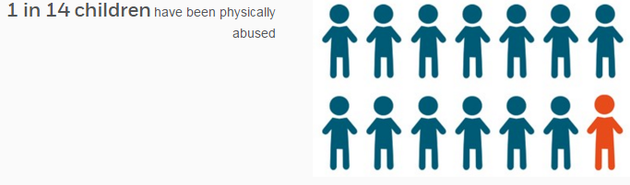©NSPCC 2016
Police recorded 9,516 cruelty & neglect offences to children under 16 in the UK (2013/14). This number is rising. There were over 120 child deaths recorded under homicide, assault or undetermined intent.
We estimate that for every child identified as needing protection from abuse, another 8 are suffering abuse
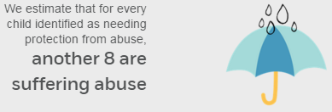©NSPCC 2016

Consider the presentation of the child, their injuries and the story (or absence) carefully. Discuss any cases which are concerning or unusual with the on call Paediatric Consultant.

Beyond this, some major trauma presentations should be discussed with the on call paediatric consultant, if concerns are obvious to the team or not:-
    - Fractures in non-mobile infants (under 1)
    - Fall from window
    - Fall down stairs in child <3 years of age
    - Knife/ gunshot/ ‘weapon’ injuries
    - Electrocution in child <8 years
    - Visceral injuries (intra-abdominal/intrathoracic), spinal injuries in the absence of confirmed major trauma
    - Injuries result from inadequate restraint (e.g. vehicle incidents)
    - Concern parents under influence of substances including alcohol
    - Submersion injuries (under 8 years, or if concerns at inadequate supervision)

SUDIC (Sudden Unexpected Death in Childhood)
The death of any child under 18 is reviewed by the Child Death Overview Panel (CDOP). There are two components
- Rapid response comprising an immediate response (in some centres this is subdivided into immediate & urgent responses- delivered by hospital and community staff respectively)
- An overview of deaths in children, undertaken by the Child Death Overview Panel
Follow the local guideline, which will list the actions required, the authorities that need notified, and practical information for the family.

