**13. (a) Management of open fractures**

**WOUND management**

1. Photograph of the wound
2. Remove gross contamination (i.e. leaves, etc.)
3. Cover the wound with saline soaked gauze dressings but do not explore or irrigate.
4. Leave wound and dressing undisturbed thereafter.
5. Check Tetanus status
6. Give ASAP Antibiotics IV according to local guidelines. Leeds as follows:
   1. **Co-Amoxiclav** 30mg/kg IV (max 1.2g) tds
   2. **True penicillin allergy: Clindamycin** 6.25 mg/kg IV (max 600mg) qds and **Gentamicin** 2.5mg/kg
7. Continue Antibiotics IV for 72hrs or until definitive skin closure
8. At Induction: single doses of **Gentamicin** 2.5mg/kg and **Teicoplanin** 10mg/kg IV (max 400mg) for initial debridement and every secondary procedure until definitive skin closure

**FRACTURE management**

1. Neurovascular Examination & Documentation
2. Align and Splint the fracture
3. Repeat Neurovascular Examination
4. XRAYs – CT imaging as required
5. Document all findings

**DEFINITIVE management**

1. Decision balanced between oncall MTC Consultant, Plastic Surgery and Vascular Surgery consultants. Complex injuries, particularly those potentially requiring local or free tissue transfer, or with neurovascular injury should be immediately transferred (A&E to A&E) to the paediatric MTC offering these resources.
2. Timing depends on other injuries and available expertise.
3. Bone and soft tissue debridement, Wound coverage and fixation should be within 24hrs
4. Severely contaminated injuries, farmyard / aquatic involvement, compartment syndrome, remain a surgical Emergency and MUST be Debrided in Theatres **ASAP**
5. **Definitive soft tissue Coverage – Fixation** optimally within 72hrs

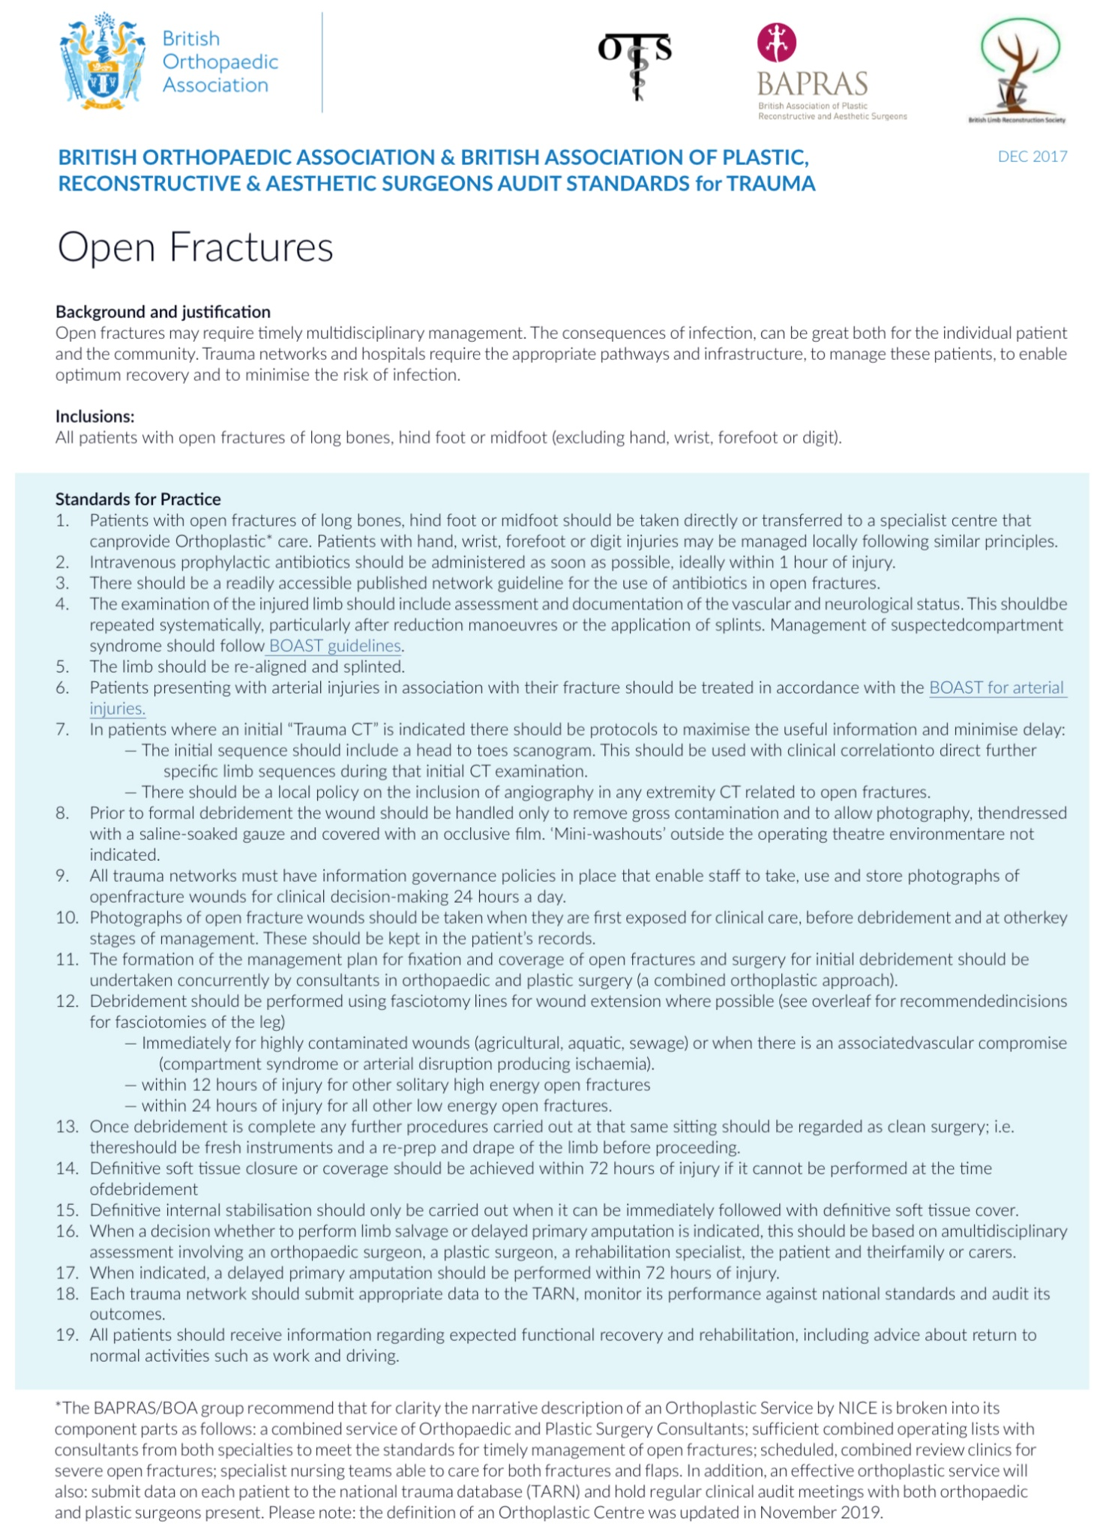

**13. (b) Management of extremity compartment syndrome**

Compartment syndrome is a severe time-dependent condition characterised by challenges to its diagnostics, straight forward therapeutic management, and detrimental irreversible consequences if it is neglected.

It arises from an increase in intra-fascial pressure in the compartments. It can affect all regions of the extremities, primarily the tibial region. Causes include direct trauma, burns and compression as a result of prolonged positioning (eg. lying on leg in an unconscious state).

**Recommended standards (adaptation of BOAST 10)**

* Assessment for compartment syndrome must be part of the routine evaluation of patients who present with significant limb injuries, OR after surgery for limb injuries, AND after any prolonged surgical procedure which may result in hypo perfusion of a limb.
* Clear documentation should include:
  + Time and Mechanism of injury
  + Time of evaluation
  + Level of Pain
  + Level of Consciousness
  + Response to Analgesia
  + Whether a Regional Anaesthetic is given.
* The key clinical findings are
  + Pain out of proportion to the associated injury
  + Pain on passive movement of the muscles of the involved compartments
  + Tense compartments painful to press
  + Limb neurology and perfusion, including capillary refill and distal pulses, should be clearly documented but do not contribute to early diagnosis of the condition.
* Patients documented to be AT RISK for compartment syndrome should have routine nursing limb observations for these early signs and these should be recorded.
* These observations should be performed hourly whilst the patient is deemed still to be at risk. If pain scores are not reducing, then SENIOR CLINICAL REVIEW i.e. ONCALL MTC / ORTHOPAEDIC CONSULTANT or ONCALL SENIOR REGISTRAR is mandated.
* In high-risk patients, regional anaesthesia should be avoided as it can mask the symptoms of compartment syndrome. In addition patient-controlled analgesia with intravenous opiates can also mask the symptoms. When evaluating these patients, the rate and dose of opiates and other analgesics must be taken into consideration and recorded in the medical records.
* Patients with symptoms or clinical signs of compartment syndrome should have all circumferential dressings released to skin and the limb elevated to heart level. Measures should be taken to maintain a normal blood pressure.
* Patients should be re-evaluated within 30 minutes. If symptoms persist then urgent surgical decompression should be performed. Alternatively, in situations where the clinician is not completely convinced by the clinical signs, compartment pressure measurements should be undertaken. All actions should be recorded in the medical records.
* Compartment syndrome is a surgical emergency and surgery should occur within an hour of the decision to operate. If the patient is in a Trauma Unit and the local expertise allows and when other life-threatening injuries are not present, then the decompressive surgery should be undertaken in the trauma unit rather than enforcing a delay with a transfer to the MTC.
* FOR PATIENTS WITH DIAGNOSTIC UNCERTAINTY and those with risk factors where clinical assessment is not possible (e.g. patients with reduced level of consciousness):
  + Intra-fascial pressures should be measured objectively and documented without delay
  + Compartment pressures exceeding 40 mmHg, OR, in the case of hypotension, exceeding a difference between the DBP (diastolic) and the intra-fascial chamber pressure of <30 mmHg are classed as critical values and are an indication for fasciotomies in the unconscious patient
  + It must be noted that the accuracy of the compartment pressure measurement depends on the examiner and can be false-positive/negative.
  + Following measurement - should either proceed to surgical decompression or continue to be monitored. This decision should be made be an orthopaedic / plastic surgical or vascular consultant.

**Surgery**

* Immediate open fascial decompression of all involved compartments, taking into account possible reconstructive options.
* Necrotic muscle should be excised. The compartments decompressed must be documented in the operation record.
* In the presence of a fracture skeletal stability should be provided, such as with monolateral external fixation.
* All patients should undergo re-exploration at approximately 48 hours, or earlier if clinically indicated. Early involvement by a plastic surgeon may be required to achieve appropriate soft tissue coverage.
* For lower leg fasciotomies it is recommended to perform a two-incision four-compartment decompression (BOAST 4).
* Patients with late presentation or diagnosis (greater than 12 hours) have a high risk of complications with surgery. Decision-making is difficult and should involve two consultants. Non-operative management is an option.
* In case of vascular reconstruction the indication for fasciotomies should be considered and applied early; if necessary it should be carried out even before the vascular reconstruction.
* Postoperatively the patient should be covered with antibiotics as per the paediatric open fracture guidelines.

